**Contents**

Chapter 1: Introduction 8

1.1 Mission Statement 8

1.2 Objectives 9

1.3 Project Goals 9

1.4 Features 10

1.5 Advantage 10

1.6 Project Outputs 10

Chapter 2: Literature Review 11

2.1 Workflow Management 11

2.2 Prepare the walkthrough 12

2.3 Requirement Engineering 12

2.4 Market research study 13

2.5 System Hierarchy 14

2.6 Project Planning 14

Chapter 3: Relationship Diagram 15

3.1 Use Case Diagram 17

3.2 Activity Diagram 18

3.3 Entity Relationship Diagram (ERD) 19

3.4 Sequence Diagram 20

3.5 Data Flow Diagram 21

3.6 Component Diagram 22

3.7 Class Diagram 23

Chapter 4: Implementation 24

4.1 Admin Login Systems 24

4.2 Home Page 24

4.3 Department Create 25

4.4 Department Views 26

4.5 Assign Course 26

4.6 Department wise course views 26

4.7 Teacher Information creates 27

4.8 Course Assign to Teacher 27

4.9 Student Information create 28

4.10 Room Allocation 28

4.11 Save Result 29

4.12 View Result 29

4.13 Room & Class Time Allocation 30

4.14 Class Schedule 30

2

Chapter 5: Conclusion and Future work 31

51: Conclusion 31

5.2 Future Work 31

References 32

3

**List of Figure:**

| Figure 1: User Hierarchy……………………………………………………………... | 14 |
| --- | --- |
| Figure 2: Use Case Diagram…………………………………………………………. 17 | |
| Figure 3: Activity Diagram…………………………………………………………... | 18 |
| Figure 4: ER Diagram………………………………………………………………... | 19 |
| Figure 5: Sequence Diagram…………………………………………………………. | 20 |
| Figure 6: Data Flow Diagram………………………………………………………... 21 | |
| Figure 7: Component Diagram………………………………………………………. | 22 |
| Figure 8: Class Diagram……………………………………………………………... | 23 |
| Figure 9: Admin Login………………………………………………………………. | 24 |
| Figure 10: Home Page………………………………………………………………… | 24 |
| Figure 11: Department Create ………………………………………………………... | 25 |
| Figure 12: Department Views……………………………………………………….. | 25 |
| Figure 13: Course Create…………………………………………………………….. | 26 |
| Figure 14: Department wise course views…………………………………………… | 26 |
| Figure 15: Creates Teacher Information ……………………………………………. | 27 |
| Figure 16: Course Assign to Teacher………………………………………………… | 27 |

Figure 17: Student Information create……………………………………………….. 28

| Figure 18: Room Allocation ………………………………………………………… | 28 |
| --- | --- |
| Figure 19: Save Result……………………………………………………………….. | 29 |
| Figure 20: View Result………………………………………………………………. | 29 |
| Figure 21: Room & Class Time Allocation………………………………………….. | 30 |
| Figure 22: Class Schedule……………………………………………………………. | 30 |

4

**Chapter-1**

**Introduction:**

The “University Management System” is an improved Student Service, increase information sharing and providing Teacher facilities. It can handle all details about a student. The details include Online course Offering, Seat allocation, student take their course by own. Student management system is managed by a Department. It is the job of the Department to insert update and monitor the whole process.

Here comes the management system of the web page and managing the pages. The system will serve the management to reduce cycle times, faster keep track of data, and improve the service, increase information sharing and providing facilities to store information centrally. I was fortunate and blessed to get this lucky break to work with this appreciable project. My earnest thanks, gratitude and salutations to those respectable people from the deep down inside my heart to make the part of this appreciable project and give me such nice opportunity. The system will do the following activities:

* Course Assignment
* Result View by Admin
* Class Routine
* Enroll Courses by Admin
* Show Departmental wise course
* Get Report
* Download PDF copy

**1.1 Mission Statement**

The project aims to develop a system is for any type of document but nothing particular. This system is revolutionary to document processing. The uniqueness is being web based and for general-purpose. Being web based makes this system available everywhere through internet. Being general-purpose means system can be used for all type of documents and for most organizations. This system is develop by MVC (Model, View, Controller) Which followed the Code first Approach .To develop a database system which can easily store, retrieve and update data.

* The system is to eliminate their manual counting of student taking a particular subject to a computerized system which can query.
* The system is to shorten the time of retrieving data when required.

5

**1.2 Objectives**

Web applications are becoming so widespread is because it offers a user friendly interface for online access from everywhere of the human race. In addition, it helps to amplify users sustain rate. This project named as “University Management System”.

This project covers the Course enrollment of students in a particular semester with the with the facility of choosing his desired time schedule. The system has some pre-defined check-points, failure to maintain check points.

A management system is the framework of policies, processes and procedures used to ensure that an organization can fulfill all tasks required to achieve its objectives.

For instance, an environmental management system enables organizations to improve their environmental performance through a process of continuous improvement. A more complete system would include accountability (an assignment of personal responsibility) and a schedule for activities to be completed, as well as auditing tools to implement corrective actions in addition to scheduled activities, creating an upward spiral of continuous improvement. Specific Objective:

* Access this system by Single user
* Length of work process
* Maximize effectiveness record and educe data
* Manual work process

**1.3 Project Goals**

The main objective of this project is to establish an integrated University Management system which enables us to automate the dynamic administrative processes in the university. This can be achieved through:

* Supporting the decision making process.
* Improving the services provided to the students, Teacher And Department.
* Improving the accuracy of the follow up and management of student data in the university.

6

**1.4 Features**

The main objective of the proposed university management system is to computerize the existing system and reduce manpower and time consumption. It provides the following features [1]:

* Maintain information of students and teachers
* Generate test results and students’ score related to respective subject and department
* Reduce error in data management
* Centralized database management
* Easy and user-friendly interface for the operator of the system
* Reduce paper work and time consumption
* Computerize the entire activities and operations
* Generate report or management take decisions.

**1.5 Advantage**

* Online CourseOffering.
* Student takes here Course
* Course Assign
* View Result
* Student Registration
* Course Registration
* Save Teacher Information
* View Course Status
* Download PDFCopy

**1.6 Project Outputs**

* Establishing a strong and effective University Management system.
* Achieving integration between developed University Management system and other available systems.
* Preparing electronic data that enables the processes entering and converting data [2].

7

**Chapter 2: Literature Review**

**2.1 Workflow Management**

This book offers a comprehensive introduction to workflow management, the management of business processes with information technology. By defining, analyzing, and redesigning an organization's resources and operations, workflow management systems ensure that the right information reaches the right person or computer application at the right time. The book provides a basic overview of workflow terminology and organization, as well as detailed coverage of workflow modeling with Petri nets. Because Petri nets make definitions easier to understand for no experts, they facilitate communication between designers and users. The book includes a chapter of case studies, review exercises, and a glossary. A special Web site developed by the authors, features animation, interactive examples, lecture materials, exercises and solutions, relevant links, and other valuable resources for the classroom [3].

* **Business Process Management Systems**

The ultimate goal of any information system is to support processes. The system itself is not to primary objective. Therefore, Business Information Systems (BIS) need to be designed and analyzed such that in the end the processes are conforming to certain response times and flow times are a short as possible, costs are reduced, and risks are minimized. Therefore, the focus of this course is one the relation between processes and systems.

The language used in this course is high- level supported by CPN (Colored Petri nets) Tools. CPN Tools is used as a tool to test ideas, to do simple simulations and other forms of analysis, and to construct basic prototypes. The course focuses on transforming informal descriptions of business processes and systems into high-level Petri nets [4]. Given an informal description, students should be able to map the control-flow perspective onto high-level Petri nets. Also mappings of the other perspectives onto abstractions understandable by computer programs are considered.

* **Workflow Management Systems (not maintained)**

This course introduces the basic concepts of workflow management. The emphasis is on modeling workflow processes and the characteristics of contemporary workflow management. Workflow processes are a specific type of operational processes typically associated with work processes in administrative environments. However, any case-driven operational process falls in this category. Workflow technology provides the functionality to support these processes. Since this technology is adopted in many enterprise information systems knowledge about these

8

systems and experience in making and enacting workflow models is relevant for students in operations management [5].

* **Unit Testing**

This walkthrough will step you through creating, running, and customizing a series of unit tests using the Microsoft unit test framework for managed code and the Visual Studio Test Explorer. You start with a C# project that is under development, create tests that exercise its code, run the tests, and examine the results. Then you can change your project code and re-run the tests [5].

**2.2 Prepare the walkthrough**

1. Open Visual Studio.
2. On the **File** menu, point to **New** and then click **Project**. The **New Project** dialog box appears.
3. Under **Installed Templates**, click **Visual C#**.
4. In the list of application types, click **Class Library**.
5. In the **Name** box, type **Student** and then click **OK**.
6. Copy the source code from the Sample Project for Creating Unit Tests.
7. Replace the original contents of Class1.cs with the code from the Sample Project for Creating Unit Tests.
8. Save the file as Student.cs
9. On the **Build** menu, click **Build Solution**.

**2.3 Requirement Engineering**

The process to gather the software requirements from client, analyze and document them is known as requirement engineering [6].

The goal of requirement engineering is to develop and maintain sophisticated and descriptive ‘System Requirements Specification’ document.

* **Requirements Analysis**

Requirement analysis is a software engineering task that creates a bridge between system Engineering and system design. It may also involve a more vigorous feedback mechanism to the requestors, pointing out where a particular system might achieve economies if it could use more common requirements. And requirements analysis has the product line scope as one of its inputs–an artifact that does not exist outside the product line context. Requirements analysis includes a commonality and variability analysis (a technique used frequently in domain analysis)

9

on the elicited product line requirements to identify the opportunities for large-grained reuse within the product line. Two such techniques are feature-oriented domain [7].

* **Requirements Elicitation**

We submit a proposal on the project entitled “University Management System” to the department chair of “EAST WEST UNIVERSITY”. Requirements elicitation for a product line must capture anticipated variations explicitly over the foreseeable lifetime of the product line. This means that the community of stakeholders is probably larger than for single-system requirements elicitation and May well include domain experts, market experts, and others. Requirements elicitation focuses on the scope, explicitly capturing the anticipated variation by the application of domain analysis techniques, the incorporation of existing domain analysis models, and the incorporation of use cases that capture the variations that are expected to occur over the lifetime of the product line. In this system we gather requirements about existing Department and course offering Management System [8] .We try to understand the user’s needs and constraints for the current system .We analyze present work process, find out the check points and process hierarchy.

In this phase we do mainly two works:

* Analyze the current process and its check points.
* Understand existing system’s constraints and user hierarchy.

**2.4 Market research study**

This is one of the most important sections of the feasibility study as it examines the marketability of the product or services and convinces readers that there is a potential market for the product or services. If a significant market for the product or services cannot be established, then there is no project. Typically, market studies will assess the potential sales of the product, absorption and market capture rates and the project's timing. The feasibility study outputs the feasibility study report, a report detailing the evaluation criteria, the study findings, and the recommendations.

10

**2.5 System Hierarchy**

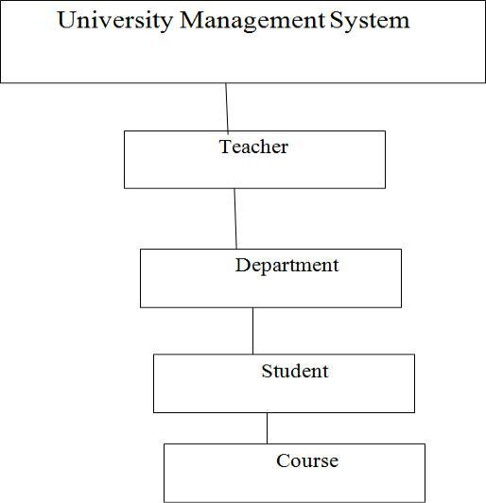

**Figure 1: User Hierarchy**

Change-management policies must provide a formal mechanism for proposing changes in the product line and supporting the systematic assessment of how the proposed changes will impact the product line. Change- management policies govern how changes in the product line requirements are proposed, analyzed, and reviewed. The coupling between the product line requirements and the core assets is leveraged by the use of traceability links between those requirements and their associated core assets. Changes in the requirements can then trigger the appropriate changes in the related core assets. The "Configuration Management" practice area describes change management in more detail [9].

**2.6 Project Planning**

Proper planning is arguably the most important aspect of any project. Without a plan projects will exceed deadlines, coders will create redundant code and many projects won’t even see the light of day. So my goal with this is to help the beginners out there so they don’t have to go through what I did as a C# programmer. Hopefully this will get you on the right track with proper project planning and creating your app using the Model View Control (MVC) design pattern.

11

**ASP.NET MVC**

ASP.NET supports three major development models: Web Pages, Web Forms and MVC (Model View Controller). The ASP.NET MVC framework is a lightweight, highly testable presentation framework that is integrated with existing ASP.NET features, such as master pages, authentication, etc. Within .NET, this framework is defined in the System.Web.Mvc assembly. The latest version of the MVC Framework is 5.0. We use Visual Studio to create ASP.NET MVC applications which can be added as template in Visual Studio.

**ASP.NET MVC Features**

The ASP.NET MVC provides the following features:

* Ideal for developing complex but light weight applications
* It provides an extensible and pluggable framework which can be easily replaced and customized. For example, if you do not wish to use the in-built Razor or ASPX View
* Engine, then you can use any other third-party view engines or even customize the existing ones.
* Utilizes the component-based design of the application by logically dividing it into Model, View and Controller components. This enables the developers to manage the complexity of large-scale projects and work on individual components.
* The MVC structure enhances the test-driven development and testability of the application since all the components can be designed interface-based and tested using mock objects. Hence the ASP.NET MVC Framework is ideal for projects with large team of web developers.
* Supports all the existing vast ASP.NET functionalities such as Authorization and Authentication, Master Pages, Data Binding, User Controls, Memberships, ASP.NET Routing, etc.
* It does not use the concept of View State (which is present in ASP.NET). This helps in building applications which are light-weight and gives full control to the developers.

Thus, you can consider MVC Framework as a major framework built on top of ASP.NET providing a large set of added functionality with focus on component-based development and testing.

12

**Chapter 3: Relationship Diagram**

**3.1 Use Case Diagram**

Use case diagrams are considered for high level requirement analysis of a system. So when the requirements of a system are analyzed the functionalities are captured in use cases. So we can say that uses cases are nothing but the system functionalities written in an organized manner. Now the second things which are relevant to the use cases are the actors. Actors can be defined as something that interacts with the system. The actors can be human user, some internal applications or may be some external applications. So in a brief when we are planning to draw an use case diagram we should have the following items identified.

* Admin Register Login, and store the student Records details in database.
* Student Register from the login Process.
* Then the database is searched for details and verified.
* Database stores the details and returns acknowledgement.

Use case diagrams are drawn to capture the functional requirements of a system. So after identifying the above items we have to follow the following guidelines to draw an efficient use case diagram

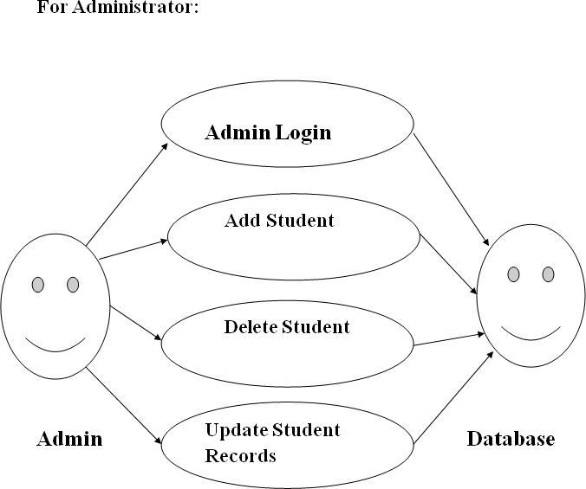

13

**For University:**

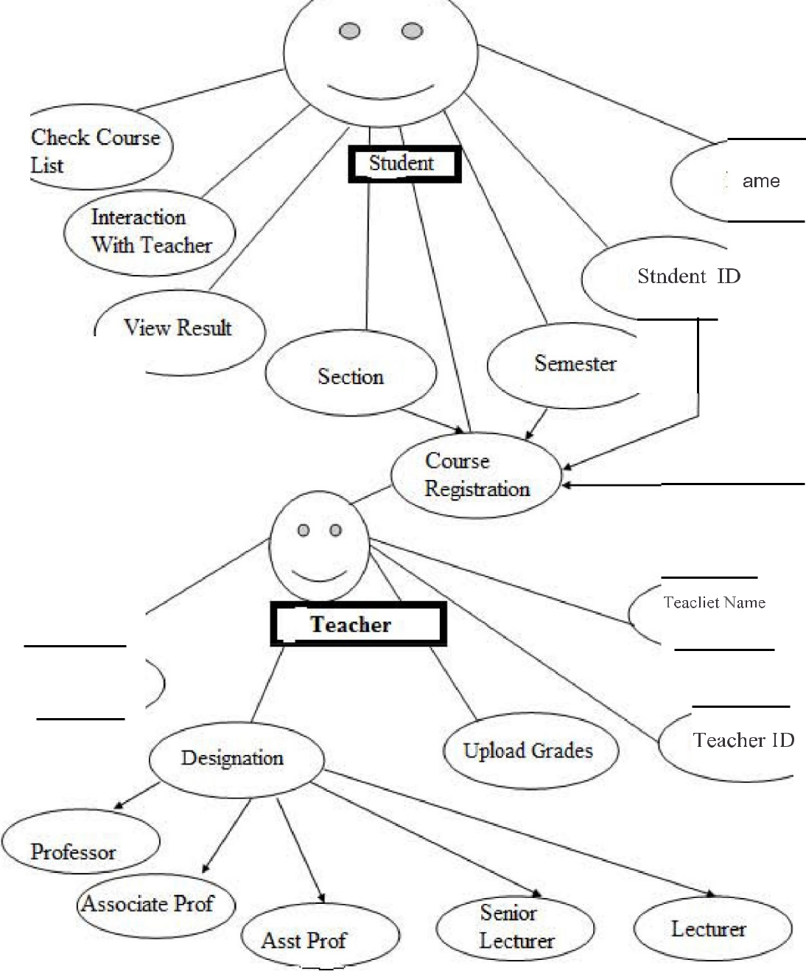

Check Srudent

List

**Figure 2: Use Case Diagram**

14

**3.2 Activity Diagram**

Activity diagram are graphical representations of workflows of stepwise activities and actions with support for choice, iteration and concurrency. An activity diagram shown as an rounded box containing the name of the operation. This activity diagram flow of stepwise activities performed in recruitment system. The student details are Add and stored in database. Select The Course from the given Course by student. Search Profile and Result With login and if Data present in the database. The searched data is displayed if available and then Logout.

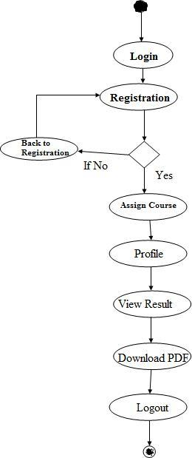

**Figure 3: Activity Diagram**

15

**3.3 Entity Relationship Diagram (ERD)**

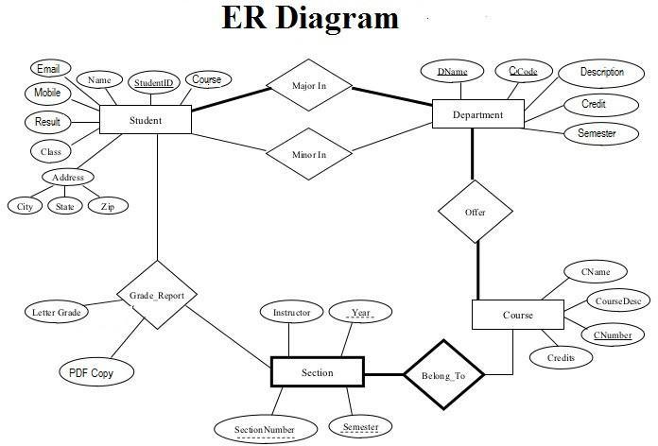

**Figure 4: ER Diagram**

This is System create for the Admin. He can stores the University Database details about university students, Teacher, Courses, Class Schedule, the semester, Result, A student took a particular course (and his mark and grade if he completed it), and what degree program each student Or Teacher is enrolled in. The database is a long way from one that’d be suitable for a large tertiary institution; I explain the requirements next and discuss their shortcomings at the end of this section. Consider the following requirements: The University offers one or more programs. A program is made up of one or more courses. A student must enroll in a program. A student takes the courses that are part of her program. A program has a name, a program identifier, the total credit points required to graduate, and the year it commenced. Each course in a program is sequenced into a year (for example, year 1) and a semester (for example, semester 1) [12].

16

**3.4 Sequence Diagram**

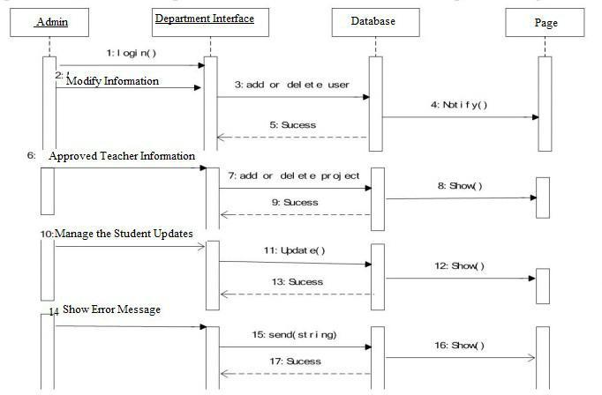

**Figure 5: Sequence Diagram**

Since the administrator have the most priority of over other participators, the main development task focus on them. The rights of administrator include the overall management of project (editing the basic information & project of tutors & students, approve, add & delete). It also contains creating the form of final approved projects. Meanwhile, they are allowed to look over the name list of students and Teachers who does not submit the application .When it operates the behavior of one instance, the inter- transferred information between subjects reflects the class operation of static molding diagram or the triggered events in state machine. The mapping between UML model benefit designers speed up to understand the problems. Therefore, the developing complexity of system will be reduced efficiently [14].

17

**3.5 Data Flow Diagram**

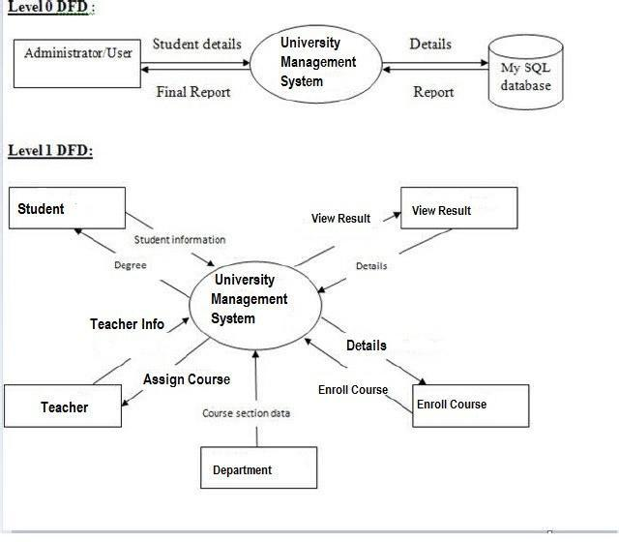

**Figure 6: Data Flow Diagram**

This system contain two level Data Flow diagram, one is Level ) DFD which contributes the Admin or User login this system. Rearrange data (updates or deletes) from the database. The Second or Level 1 DFD which arrange for the student Teacher And Department .Student Or Teacher Assign Courses. Student should find out the Result and enroll the courses.

18

**3.6 Component Diagram**

The Management connector is a "connector between two components that defines that one component provides the services that another component requires. Management connector is a connector that is defined from a required interface or port to a provided interface or port.

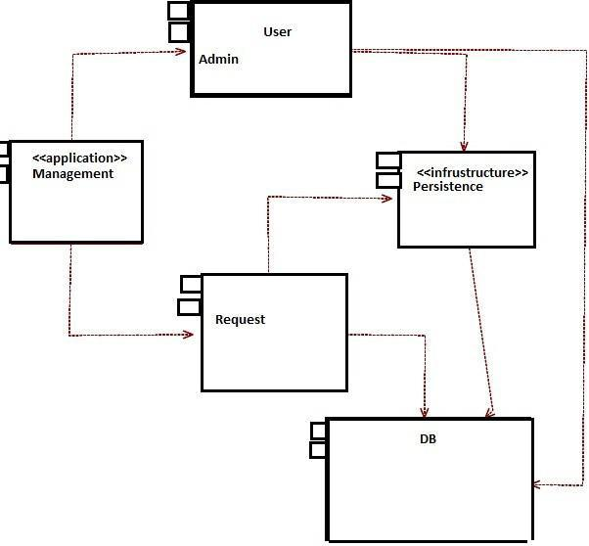

**Figure 7: Component Diagram**

19

**3.7 Class Diagram:**

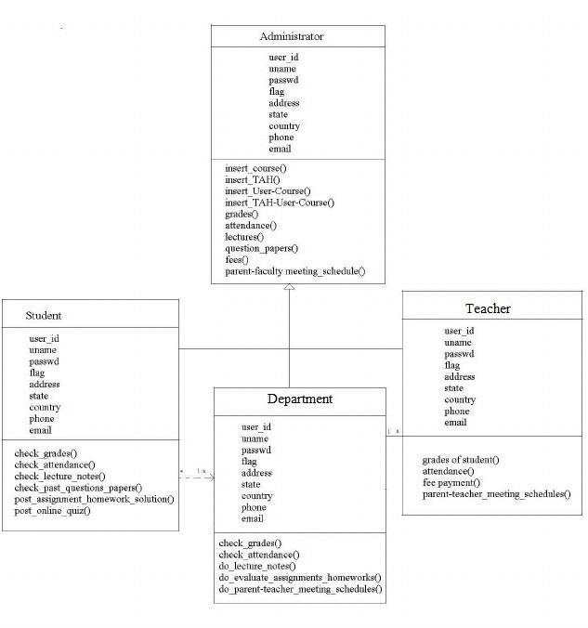

**Figure 8: Class Diagram**

This class diagram has three classes Login, Student details and Updatedetails in database. a. Student is the class name. Its attributes are name, "address, Result, 'PDF Copy Download, Subjects Semester, degree. The operations performed in the student’s class, Store database and Update.

20

**Chapter 4: Implementation**

**4.1 Admin Login Systems**

Admin has a user Id which gives in the database. It will auto generate .Admin should Registration and login the page.

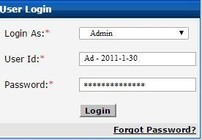

**Figure 9: Admin Login**

**4.2 Home Page**

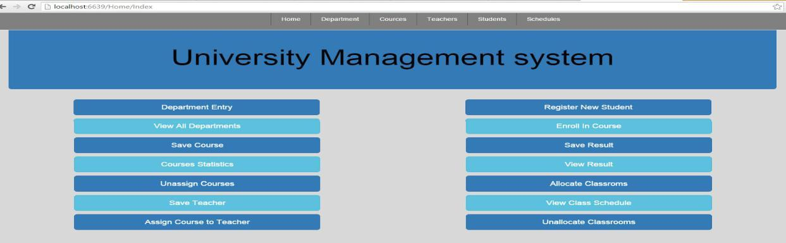

**Figure 10:** **Home Page**

21

University manage is a online web-based management software which is specially designed and developed for the universities, colleges and other educational Institutions. The software provides services for every modules of the university which makes the work more efficient and consumes less time for retrieving the data. This software contains different modules such as student & Teachers Advising, Auto timetable, classroom allocation And Result Report. It shows the home pages which have many categories, Admin should change any data for this page, and Admin always update and delete the information.

**4.3 Department Create**

Under this menu of University management system Create Department, first input the department code then written the whole name.

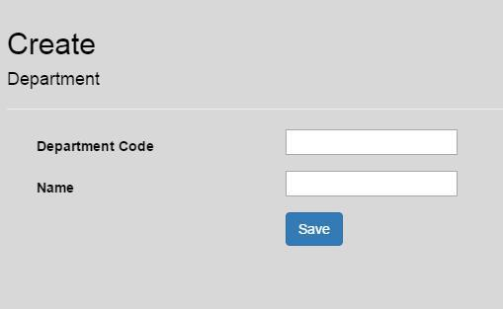

**Figure 11: Department Create**

**4.4 Department Views**

When create the all department then view the all inputs

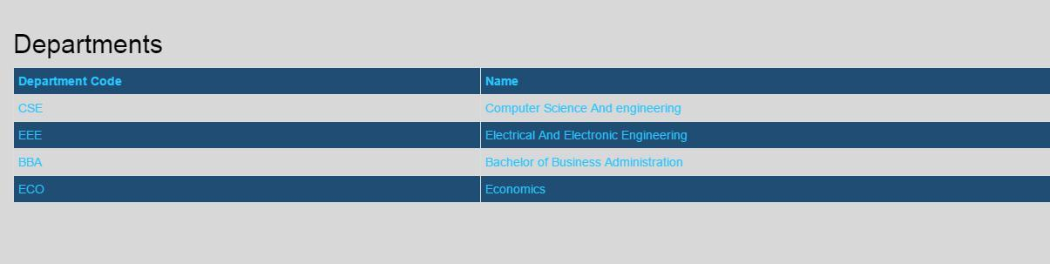

**Figure 12: Department Views**

22

**4.5 Assign Course**

Create Course, which contains course code, course Name, Credit, description of this course, department allocation, which semester allocated for this courses.

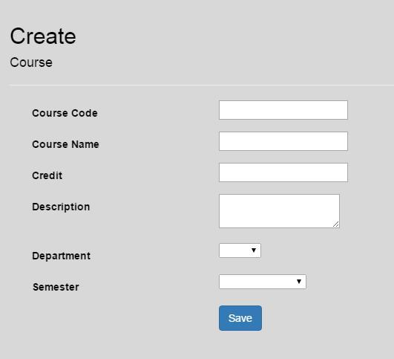

**Figure 13: Assign Course**

**4.6 Department wise course views**

When create the courses then search the department wise course, this contains course title, semester and assign to, if the teacher assign this courses then show the course is assign to someone .

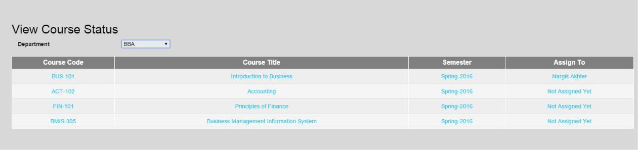

**Figure 14: Department wise course views**

23

**4.7 Teacher Information creates**

Create a teacher biography which contain teachers name address email and contact number, teacher designation, which department is assign for the teacher. And the credit number.

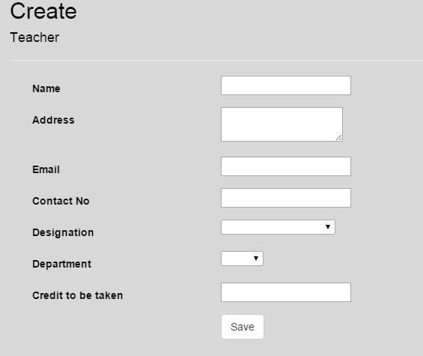

**Figure 15: creates Teacher Information**

**4.8 Course Assign to Teacher**

Courses assign to the teacher, teacher taken the total credit, teacher’s department name, course code course code both are related for this steps.

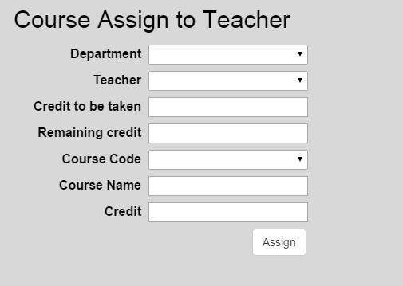

**Figure 16: Course Assign to Teacher**

24

**4.9 Student Information create**

Then create the student information,that contains student name ,mail address ,contact number ,student address and which department he or she is reading.

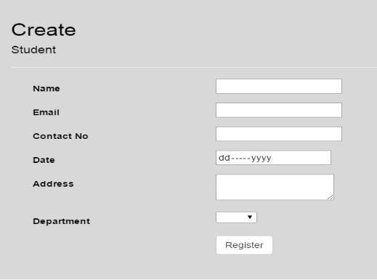

**Figure 17: Student Information create**

**4.10 Room Allocation**

Under this menu Room allocation is the most important things for the university mangement system,you can types the department name ,course code room number day and time then create the Room for the subject for a semester.if same time same room same day have to create this that time it could be show the overloop.this is very important for a room allocation.

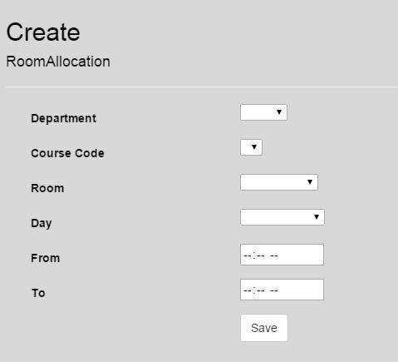

**Figure 18: Room Allocation**

25

**4.11 Save Result**

There a Registration number or Student Id Auto Generate form the database, and also show the student Name, Email, Department, then select the course and input his/her grade and save this.

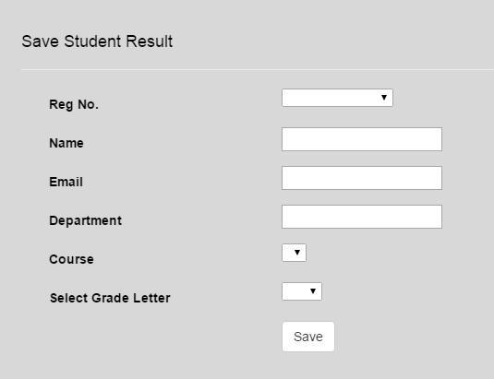

**Figure 19: Save Result**

**4.12 View Result**

When input the student registration Number then it show student all details and student result sheet.

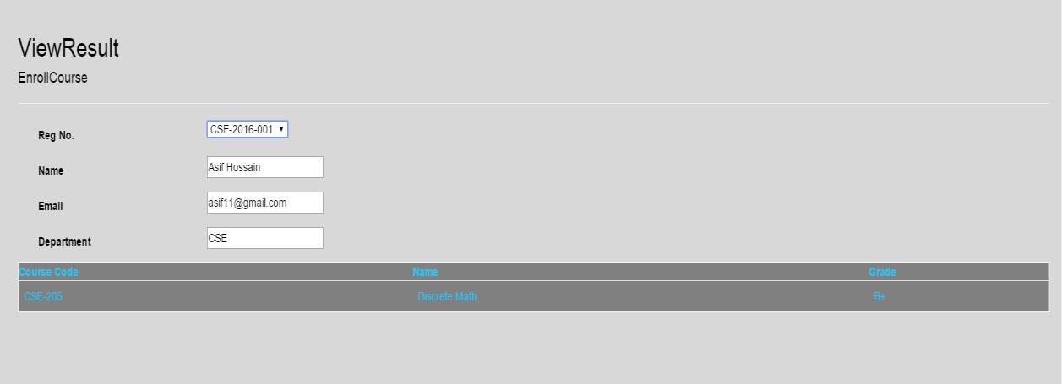

**Figure 20: View Result**

26

**4.13 Room & Class Time Allocation**

Select the department Name, Course code, Room number, Day, and the class time then it save in the database.

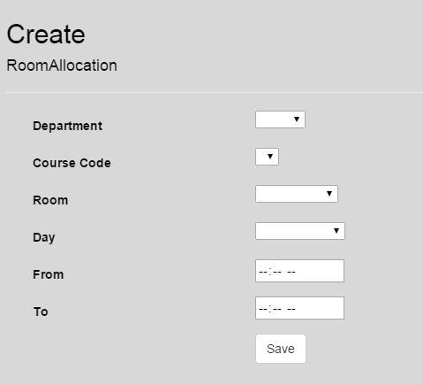

**Figure 21: Room & Class Time Allocation**

**4.14 Class Schedule**

It shows the class schedule and Room number and student information.

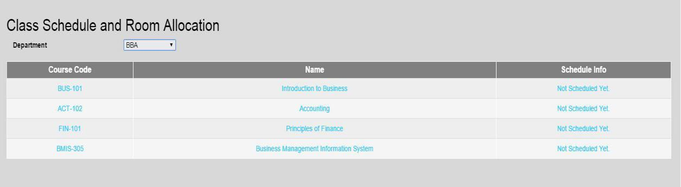

**Figure 22: Class Schedule**

27

**Chapter 5: Conclusion and Future work**

**5.1 Conclusion**

Great skills have been achieved during the development of this project, time management being one of them, research in various areas of web and database development and at the end of the day it can be said that the task has been a great success incorporated with extraordinary challenges. All in all the sleepless nights, stressful days and hard work have paid off and besides some good moments were also experienced. These experiences will be used for ever.

On my Graduation course I learned many theoretical comprehensions. Using that knowledge and Observing live operational system. My project is a fundamental approach of these.

I develop the project “University Management System”.

**5.2 Future Work**

I also want to modify my application for the Future Work .I hope this work will help me in my future work.

* The aim of this project is to manage each and every section. Such as every Student, Teacher and Staff.
* There will be a system for downloading Admission form For New Applicant.
* It will show every updated notice given by the university authorities.

28

**References**

1. https://msdn.microsoft.com/en-[us/library/f3st0d45.aspxhttp://searchcrm.techtarget.com/sDefinition/0,,sid11_gci333128,00.html](http://searchcrm.techtarget.com/sDefinition/0%2C%2Csid11_gci333128%2C00.html) accessed on (17/03/09)
2. <http://docs.asp.net/en/latest/dnx/projects.html>
3. Bergner, Terry; Steiny, Julia and Armstrong, Jane. (2007). Benefits of and Lessons Learned from Linking Teacher and Student Data. National Center for Educational Accountability, Data Quality Campaign. [www.DataQualityCampaign.org](http://www.dataqualitycampaign.org/)
4. Berry, Barnett. (2007). Connecting Teacher and Student Data: Benefits, Challenges and Lessons Learned. Center for Teaching Quality. [www.teachingquality.org](http://www.teachingquality.org/)
5. Borden, Victor M.H. (1995). Harnessing New Technologies for Student Tracking. In P.T. Ewell (Ed), Student Tracking: New Techniques, New Demands (New Directions in Institutional Research #87, pp.55-67. San Francisco: Jossey-Bass.
6. Cunningham, A. F., and Milam, J. (2005). Feasibility of a Student Unit Record System within the Integrated Postsecondary Education Data System (NCES 2005-160). U.S. Department of Education, National Center for Education Statistics, Washington, DC: U.S. Government Printing Office.
7. https://msdn.microsoft.com/library/ez524kew (v=vs.110).aspx
8. <http://www.tutorialspoint.com/asp.net/>
9. Pressman, Roger S., Software Engineering: A Practitioner’s Approach. McGraw-Hill, 2001.
10. <http://www.troyhunt.com/2013/10/10-ways-to-make-your-net-projects-play.html>
11. <http://docs.telerik.com/kendo-ui/aspnet-mvc/asp-net-mvc-4>
12. https://msdn.microsoft.com/en-us/data/gg685467.aspx

29

1. <http://www.codeproject.com/Articles/826571/Code-First-Approach-with-ASP-NET-MVC->Framework
2. <http://www.codeproject.com/Tips/869986/CRUD-operation-with-Entity-Framework-Code->First
3. <http://www.c-sharpcorner.com/UploadFile/abhikumarvatsa/code-first-approach-in-entity->framework/
4. https://en.wikipedia.org/wiki/C_Sharp_(programming_language)

30